**Chapter 7 – Memory Tech introduction**

* A register is storage for single value for quick access/readily available
* Memory is designed to store the code and data of programs during execution
* Storage memory technologies require less H/W than flip-flop
* Will go over commonly used memory technologies and their applications
* Storage size is defined in terms of bytes

Unit Reads Approximate Size

1kb One Kilobyte 10^3 Bytes

1MB One Megabyte 10^6 Bytes

1 GB One Gigabyte 10^9 bytes

1 TB One Terabyte 10^12 Bytes

* Memory technologies are categorized as Read only memory or Random-Access memory
* ROM memory is nonvolatile and retains their content even when they are not powered
* RAM are volatile and would lose their content when not powered
* Examples of Non-Volatile memory technologies are magnetic disks, flash memory and optical disk such as CD ROM’s
* The content of a ROM cell is fixed at logic 0 or 1
* An Electrically erasable PROM (EEPROM) is most commonly used today
* EEPROM cells can be programmed only a certain number of times
* Ram’s functions as the Main storage for programs and data
* SRAM vs DRAM
  + SRAM is preferable for register files and L1/L2 caches
    - Faster access time
    - No Refreshes needed
    - Simpler Manufacturing.
    - Lower density
* DRAM is preferable for stand alone memory chips
  + Much higher capacity per area
  + Higher density.
  + Lower cost – i.e. cost vs performance trade off.
  + Continuously refreshed to keep the capacitors charged up.
* A memory timing diagram precisely illustrates memory communication protocols.
* Time required to select target cells and perform a read or write operation is called a memory access time
* A memory cycle includes both an access time and data transfer time.
* The access time is directly proportional to the size of the memory cell array.
* The decoders in turn determine the time required to activate a target row and access target cells

1. Peak Memory Bandwidth Exercise

Example 1: Consider a 32-bit data bus SDRAM. Given that the clock frequency of the bus is 100MHz, what is the peak memory bandwidth in megabyte per second (MBs)?

32 -bit data bus:

1 byte = 8 bits, so 32 bits x 1 byte/8bits = 4Bytes per cycle

1 MB = 1,000,000 Bytes

1 Hz = 1 cycle/sec

1 MHz= 1 million Hz = 1,000,000 * 1 cycle/sec = 1,000, 000 cycles/sec

100 MHz = 100 Million Hz = 100 Million * 1 cycle/sec = 100,000,000 cycles/sec

100,000,000 cycle/sec   *   4 Bytes/cycle = 400,000,000 Bytes/sec

400,~~000,000~~ ~~Bytes~~/sec * 1MB/1,~~000,000~~ ~~Bytes~~ = 400 MB/sec

**7.5.1 SRAM**

Figure 7.16 illustrates an SRAM read cycle from the memory point of view.

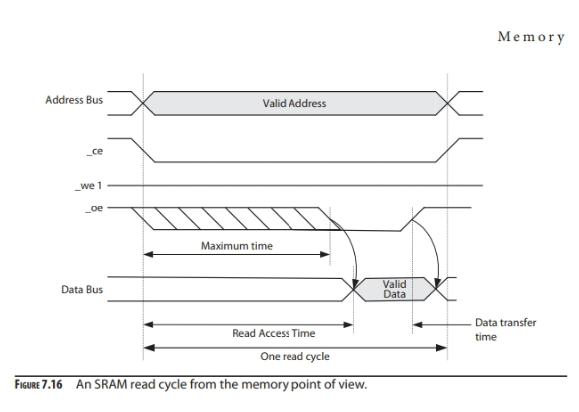

Figure 7.17 illustrates an SRAM memory write cycle.

A memory cycle is initiated by CPU and typically takes multiple CPU clock cycles to complete.

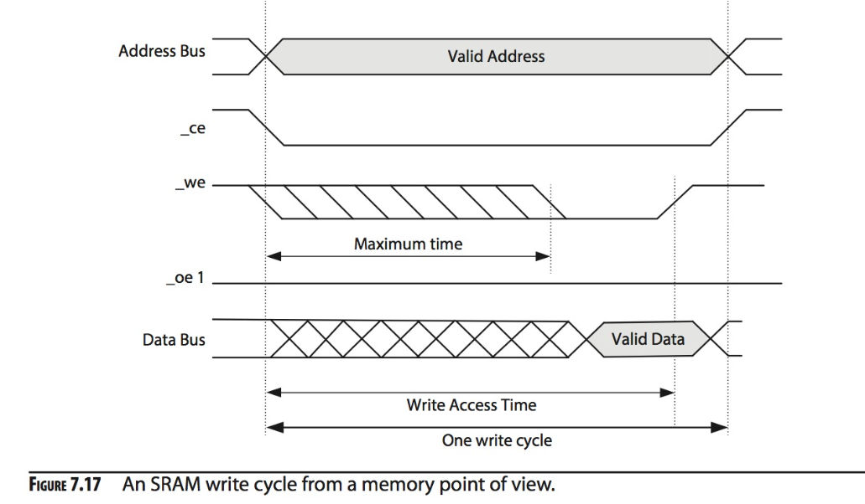

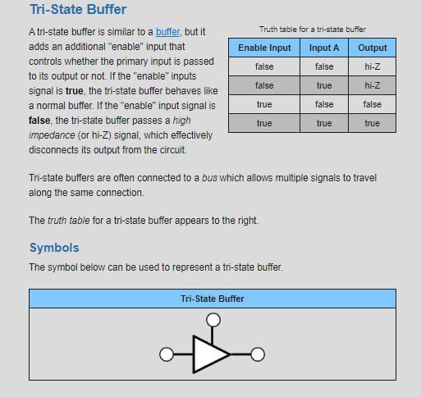

 tri-state buffer is similar to a [buffer](https://logic.ly/lessons/buffer/), but it adds an additional "enable" input that controls whether the primary input is passed to its output or not. If the "enable" inputs signal is **true**, the tri-state buffer behaves like a normal buffer. If the "enable" input signal is **false**, the tri-state buffer passes a *high impedance* (or hi-Z) signal, which effectively disconnects its output from the circuit.

Tri-state buffers are often connected to a *bus* which allows multiple signals to travel along the same connection.

The *truth table* for a tri-state buffer appears to the right.